Question 1: Classroom marks system
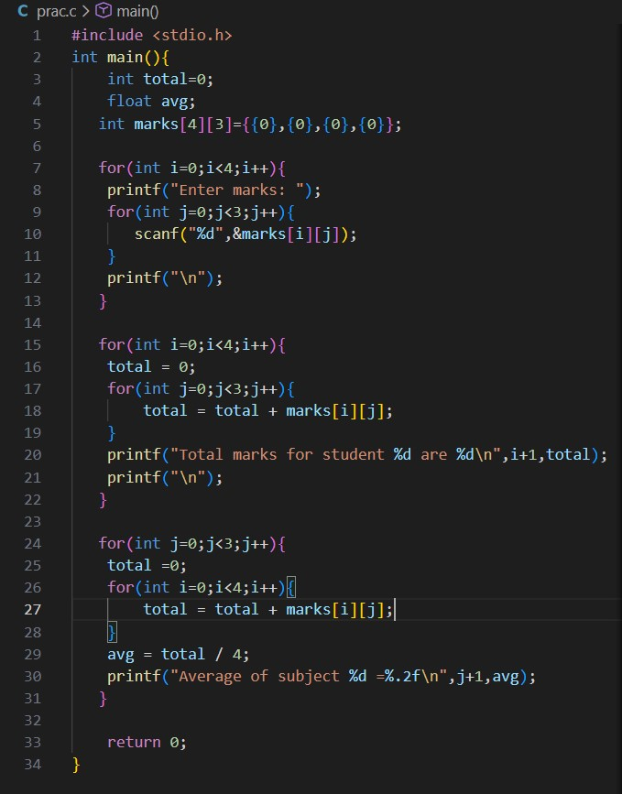
Output:
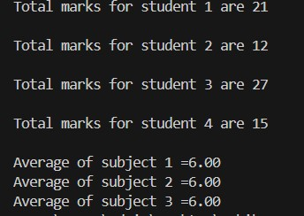
Question 2: Cinema Seat booking
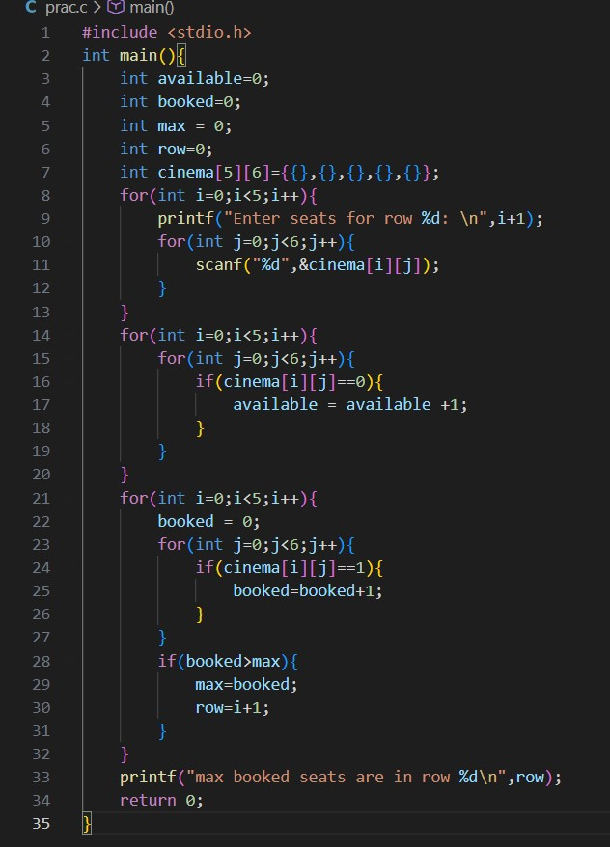
Question 3: Temperature Monitoring System
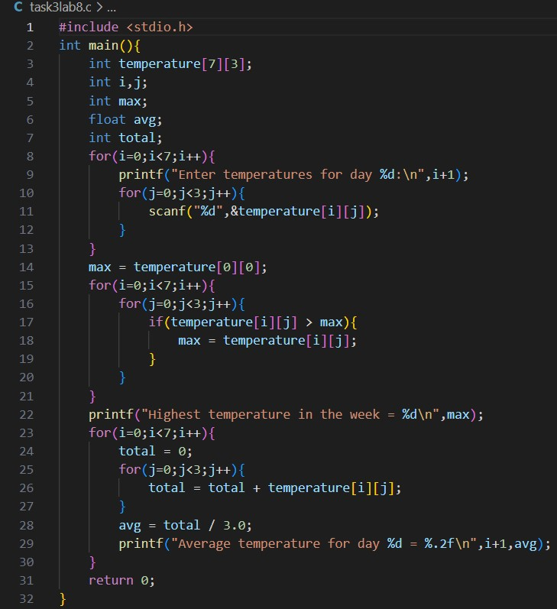
Output:
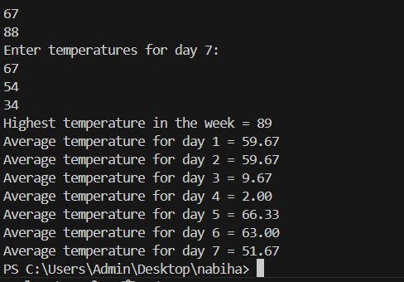
Question 4:
#include <stdio.h>
int main()
{ int a[3][3],t[3][3],co[3][3],adj[3][3]; int i,j,det;
printf("Enter 3x3 matrix:\n");
for(i=0;i<3;i++){ for(j=0;j<3;j++){ scanf("%d",&a[i][j]);
}
}
printf("\nMatrix:\n"); for(i=0;i<3;i++){ for(j=0;j<3;j++){ printf("%d ",a[i][j]);
} printf("\n");
}
// Transpose for(i=0;i<3;i++){ for(j=0;j<3;j++){
t[j][i]=a[i][j];
}
}
printf("\nTranspose:\n"); for(i=0;i<3;i++){ for(j=0;j<3;j++){ printf("%d ",t[i][j]);
} printf("\n");
}
// Determinant det = a[0][0]*(a[1][1]*a[2][2]-a[1][2]*a[2][1]) - a[0][1]*(a[1][0]*a[2][2]-a[1][2]*a[2][0]) + a[0][2]*(a[1][0]*a[2][1]-a[1][1]*a[2][0]);
printf("\nDeterminant = %d\n",det);
// Cofactor co[0][0]=(a[1][1]*a[2][2]-a[1][2]*a[2][1]); co[0][1]=-(a[1][0]*a[2][2]-a[1][2]*a[2][0]); co[0][2]=(a[1][0]*a[2][1]-a[1][1]*a[2][0]);
co[1][0]=-(a[0][1]*a[2][2]-a[0][2]*a[2][1]); co[1][1]=(a[0][0]*a[2][2]-a[0][2]*a[2][0]); co[1][2]=-(a[0][0]*a[2][1]-a[0][1]*a[2][0]);
co[2][0]=(a[0][1]*a[1][2]-a[0][2]*a[1][1]); co[2][1]=-(a[0][0]*a[1][2]-a[0][2]*a[1][0]); co[2][2]=(a[0][0]*a[1][1]-a[0][1]*a[1][0]); printf("\nCofactor Matrix:\n"); for(i=0;i<3;i++){ for(j=0;j<3;j++){
printf("%d ",co[i][j]);
} printf("\n"); }
// Adjoint for(i=0;i<3;i++){ for(j=0;j<3;j++){ adj[i][j]=co[j][i];
}
}
printf("\nAdjoint Matrix:\n"); for(i=0;i<3;i++){ for(j=0;j<3;j++){ printf("%d ",adj[i][j]);
} printf("\n"); }
// Inverse if(det!=0){ printf("\nInverse Matrix:\n"); for(i=0;i<3;i++){ for(j=0;j<3;j++){ printf("%.2f ",adj[i][j]/(float)det);
} printf("\n");
}
} else{ printf("\nInverse does not exist\n");
}
return 0;
}
Question 5:
#include <stdio.h> int main() { int a[5][5]; int rows, cols;
int i, j;
int isSquare = 1, isZero = 1, isIdentity = 1, isDiagonal = 1; int isScalar = 1, isUpper = 1, isLower = 1, isSymmetric = 1, isSkew = 1; int isRow = 0, isCol = 0, isNull = 1; int detCheck = 0; int diagonalVal = 0;
printf("Enter number of rows (max 5): "); scanf("%d", &rows); printf("Enter number of columns (max 5): "); scanf("%d", &cols);
printf("Enter matrix elements:\n"); for(i=0;i<rows;i++){ for(j=0;j<cols;j++){ scanf("%d", &a[i][j]); if(a[i][j] != 0) isZero = 0; if(a[i][j] != 0) isNull = 0;
}
}
if(rows == cols) { isSquare = 1; diagonalVal = a[0][0]; for(i=0;i<rows;i++){ for(j=0;j<cols;j++){ if(i==j && a[i][j] != 1) isIdentity = 0; if(i!=j && a[i][j] != 0) { isIdentity = 0; isDiagonal = 0; isScalar = 0;
}
if(i==j && a[i][j] != diagonalVal) isScalar = 0;
}
}
for(i=0;i<rows;i++){ for(j=0;j<cols;j++){ if(i>j && a[i][j] != 0) isUpper = 0; if(i<j && a[i][j] != 0) isLower = 0;
}
}
for(i=0;i<rows;i++){ for(j=0;j<cols;j++){ if(a[i][j] != a[j][i]) isSymmetric = 0; if(a[i][j] != -a[j][i]) isSkew = 0;
}
}
if(rows == 2) { int det = a[0][0]*a[1][1] - a[0][1]*a[1][0]; detCheck = (det != 0);
} else if(rows == 3) { int det = a[0][0]*(a[1][1]*a[2][2]-a[1][2]*a[2][1]) - a[0][1]*(a[1][0]*a[2][2]-a[1][2]*a[2][0]) + a[0][2]*(a[1][0]*a[2][1]-a[1][1]*a[2][0]); detCheck = (det != 0);
} else { detCheck = -1;
}
} else { isSquare = 0;
}
if(rows == 1) isRow = 1; if(cols == 1) isCol = 1;
printf("\nMatrix Types:\n"); if(isSquare) printf("1. Square Matrix\n"); if(!isSquare) printf("2. Rectangular Matrix\n"); if(isZero) printf("3. Zero Matrix\n"); if(isIdentity) printf("4. Identity Matrix\n"); if(isDiagonal) printf("5. Diagonal Matrix\n"); if(isScalar) printf("6. Scalar Matrix\n"); if(isUpper) printf("7. Upper Triangular Matrix\n"); if(isLower) printf("8. Lower Triangular Matrix\n"); if(isSymmetric) printf("9. Symmetric Matrix\n"); if(isSkew) printf("10. Skew-Symmetric Matrix\n"); if(detCheck == 1) printf("11. Non-Singular Matrix\n"); if(detCheck == 0) printf("11. Singular Matrix\n"); if(isRow) printf("13. Row Matrix\n");
if(isCol) printf("14. Column Matrix\n"); if(isNull) printf("15. Null Matrix\n");
return 0;
}
Question 6: #include <stdio.h>
int main() { int a[3][3], b[3][3], result[3][3]; int r1, c1, r2, c2; int i, j, k;
printf("Enter rows and columns of first matrix (max 3x3): "); scanf("%d %d", &r1, &c1); printf("Enter rows and columns of second matrix (max 3x3): "); scanf("%d %d", &r2, &c2);
if(c1 != r2) {
printf("Matrix multiplication not possible. Columns of first matrix must equal rows of second matrix.\n"); return 0; }
printf("Enter elements of first matrix:\n"); for(i=0;i<r1;i++){ for(j=0;j<c1;j++){ scanf("%d", &a[i][j]); }
}
printf("Enter elements of second matrix:\n"); for(i=0;i<r2;i++){ for(j=0;j<c2;j++){ scanf("%d", &b[i][j]); } }
for(i=0;i<r1;i++){ for(j=0;j<c2;j++){ result[i][j] = 0; for(k=0;k<c1;k++){ result[i][j] += a[i][k] * b[k][j]; }
} }
printf("\nFirst Matrix:\n"); for(i=0;i<r1;i++){ for(j=0;j<c1;j++){ printf("%d ", a[i][j]); } printf("\n"); }
printf("\nSecond Matrix:\n"); for(i=0;i<r2;i++){ for(j=0;j<c2;j++){ printf("%d ", b[i][j]); } printf("\n");
}
printf("\nResultant Matrix (Multiplication):\n"); for(i=0;i<r1;i++){ for(j=0;j<c2;j++){ printf("%d ", result[i][j]); } printf("\n"); }
return 0;
}

